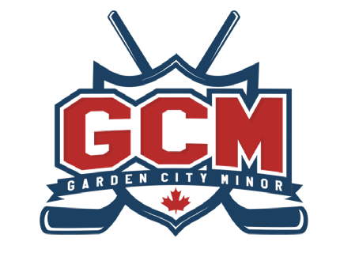
Garden City Minor Hockey Association
INDIVIDUAL AWARDS

BRUCE “BRONCO” HORVATH AWARD
In his honour, GCMHA has set up a $500.00 bursary award towards post-secondary education.
The recipient of this award will be a graduating U18 player currently with GCMHA. He/she will be an outstanding team player who exemplifies strong educational values and academic grades. They will possess and promote good character on and off the ice and is active in the community (please include a short write-up and the grade point average of the recipient).

Selected by the Head Coaches of the U18 AA and U18 A teams.

Team:

Coach Name:

Name of Player:

Position Played:

About This Player:

